**Passenger Service System**

Project

by

**Priyadarsini.N**

**(09bit139)**

Under the guidance of

**Prof: Ramya**



**School of Information Technology and Engineering**

**VIT UNIVERSITY**

Vellore – 632014, TN, India

**Introduction:**

A PSS or Passenger Service Systems is a series of critical systems used by airlines. The PSS usually comprises an [Airline Reservation System](http://en.wikipedia.org/wiki/Airline_Reservation_System), an Airline Inventory System.

Generally the PSS is made up of modules that are used to manage different parts of the airline’s business.

The [Airline Reservation System](http://en.wikipedia.org/wiki/Airline_Reservation_System) is the system that allows an airline to sell their inventory (seats). It contains information on schedules and fares and contains a database of reservations (or [Passenger Name Records](http://en.wikipedia.org/wiki/Passenger_Name_Record)) and of tickets issued.

In this there will be a administrator login and a customer login. The administrator maintains the database related to the flights and the list of tickets available. He can log-in to his personal account and can update or modify the database.

There is a user sign-up module, which provides the user to create their account with its secured password. The user can log-in into his account and can book and print air ticket. The safe logout sessions provided for security purpose. User can be able to change and recover the password. Users can be able to give their feedback.

The Airline Inventory System may or may not be integrated with the Reservation System. The system contains all the airline’s flights and the available seats. The main function of the Inventory System is to define how many seats are available on a particular flight by opening or closing an individual booking class in accordance with rules defined by the airline.

Earlier, the Airline Reservation Systems (ARS) used to be standalone systems. Each airline had its own system, disconnected from other airlines or ticket agents, and usable only by a designated number of airline employees. Travel agents in the 1970s pushed for access to the airlines' systems. Today, air travel information is linked, stored, and retrieved by a network of Computer Reservations Systems (CRS), accessible by multiple airlines and travel agents. The global distribution system (GDS) makes for an even larger web of airline information, not only merging the buying and selling of tickets for multiple airlines, but also making the systems accessible to consumers directly. GDS portals and gateways on the Web allow consumers to purchase tickets directly.

Chat application between the users and the administrator is developed. Using this facility the customer can take the suggestion of the administrator.

In order to print the ticket, my website is connected to the local machines print drivers.

**Problem Statement:**

The definition of our problem lies in manual system and afully automated system.

**Manual system**: The system is very time consuming and lazy. This system is more prone to errors and sometimes the approach to various problems is unstructured.

**Technical system**: With the advent of latest technology if we do not update our system then our business result in losses gradually with time. The technical systems contains the tools of latest trend i.e. computers printers, fax, Internet etc. The systems with this technology are very fast, accurate, user-friendly and reliable.

**Need of Passenger Service Systems:**

A few factors that direct us to develop a new system are given below -:

1) Faster System

2) Accuracy

3) Reliability

4) Informative

5) Reservations and cancellations from anywhere to any place.

**Requirements:**

**Hardware Requirements:**

* Processor Intel Core Duo2Ghz
* Memory 1 GB(min)
* Hard disk 60GB(min)

**Software Requirements:**

Operating System Microsoft Windows XP

Front-end programming asp.net

Scripting language VB(Visual Basic)

Database support SQL Server

Development Environment Microsoft Visual Studio 2008

**FEATURES OF THE PROPOSE SYSTEM:**

**Safe logouts using sessions:** Logging out automatically when the wesite is kept idle for some particular period of time.

**Password recovery:** It is used to recover and reset the passwords for lost or forgotten accounts.

**Individual Accounts:** Each and every user can open a new personal account from sign-up button

**Customer to book his ticket:** customer can log-in into his account and can book the ticket

**Admin 2 ctrl all activates add or delete items:** To maintain the appropriate database.

**Feedbacks and faq's:** To know the users opinion about the website.

Sitemap: To provide the clear idea about the website.

# SOFTWARE REQUIREMENT ANALYSIS

## FEASIBILITY STUDY

Feasibility study is an important phase in the software development process. It enables the developer to have an assessment of the product being developed It refers to the feasibility study of the product in terms of outcomes of the product, operational use and technical support required for implementing it.

Feasibility study should be performed on the basis of various criteria and parameters. The various feasibility studies are:

* Economic Feasibility
* Operational Feasibility
* Technical Feasibility

## ECONOMIC FEASIBILITY

It refers to the benefits or outcomes we are deriving from the site compared to the total cost we are spending for developing the website. If the benefits are more or less the same as the older system, then it is not feasible to develop the product.

In the present system, the development of the new product greatly enhances the accuracy of the system. The errors can be greatly reduced and at the same time providing a great level of security. Here we don’t need any additional equipment except memory of required capacity.

## OPERATIONAL FEASIBILITY

It refers to the feasibility of the product to be operational. It includes the study of additional human resource required and their technical expertise. In the present system, all the operations can be performed easily compared to existing system and supports for the backlog data.

## TECHNICAL FEASIBILITY

It studies the pros and cons of using particular software for the development and its feasibility.

In the present system, the user interface is user friendly and does not require much expertise and training. The software that is used for developing is server pages fully are highly suitable for the present application with security. This is achieved through integration of web server and database server in the same environment.

## GENERAL METHODOLOGY IN DEVELOPING SOFTWARE PROJECT

The general methodology in developing a system in involved in different phases, which describe the system’s life cycle model for developing software project. The concept includes not only forward motion but also have the possibility to return that is cycle back to an activity previously completed. This cycle back or feedback may occur as a result of the failure with the system to meet a performance objective or as a result of changes in redefinition of system activities. Like most systems that life cycle of the computer-based system also exhibits distinct phases.

Those are,

1. Requirement Analysis Phase
2. Design Phase
3. Development Phase
4. Coding Phase
5. Testing Phase

**REQUIREMENT ANALYSIS PHASE**

This phase includes the identification of the problem, in order to identify the problem; we have to know information about the problem, the purpose of the evaluation for problem to be known. We have to clearly know about the people requirements and the objectives of the project.

**DESIGN PHASE**

Software design is a process through which the requirements are translated into a representation of software. One of the software requirements have been analyzed and specified, the software design involves three technical activities: design, coding generation and testing. The design of the system is in modular form i.e. the software is logically partitioned into components that perform specific functions and sub functions. The design phase leads to modules that exhibit independent functional characteristics.

It even leads to interfaces that reduce the complexity of the connections between modules and with the external environment. The design phase is of main importance because in this activity, decisions ultimately affect the success of software implementation and maintenance.

**DEVELOPMENT PHASE**

The development phase includes choosing of suitable software to solve the particular problem given. The various facilities and the sophistication in the selected software give a better development of the problem.

**CODING PHASE**

The coding phase is for translating the design of the system-produced during the design phase into code in a given programming language, which can be executed by a computer and which performs the computation specified by the design.

**TESTING PHASE**

Testing is done in various ways such as testing the algorithm, programming code; sample data debugging is also one of following the above testing.

**Architecture Specification:**

The architecture of the Airline Reservation System is based on the three-tier architecture. This three-tier architecture mainly consists of three layers namely-Presentation Tier, Business Tier, Data Access Tier. The Presentation Tier converts and displays information into a human legible form. This tier displays information related to services such as browsing the Airline website, purchasing tickets etc. It communicates with the other tiers by outputting results to the browser/client tier and all the other tiers. The Business Logic tier is mainly responsible for information exchange between the user interface and the database of the project. The final layer of the three tiered architecture is the Data Access tier, which mainly consists of the Database servers. The information related to the Airline Reservation System is stored and retrieved from here

[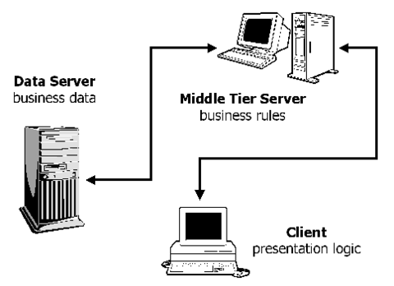](http://www.linuxjournal.com/articles/lj/0075/3508/3508f3.png)

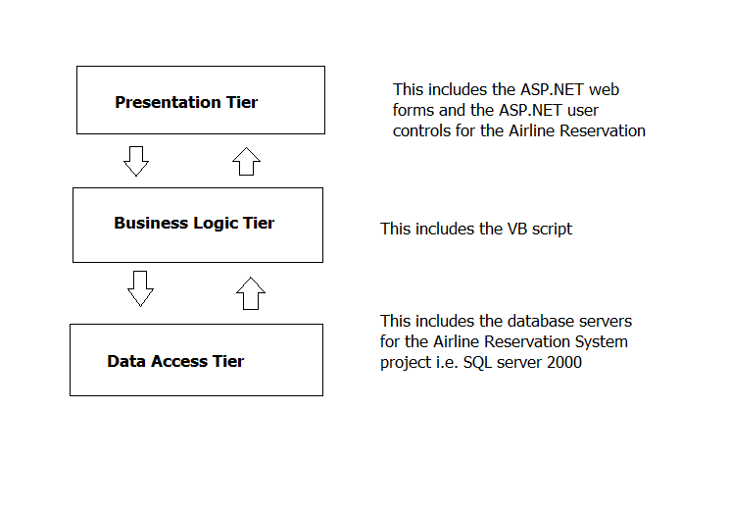

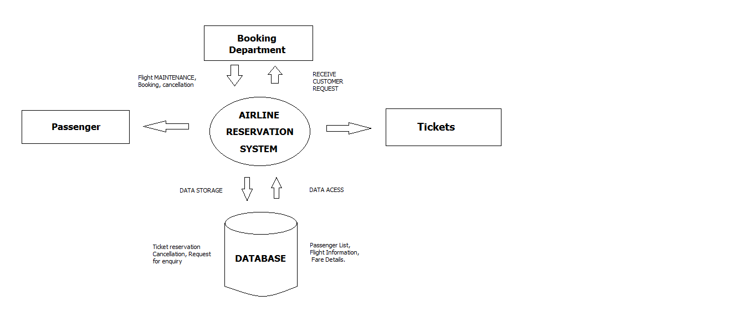

**Class Diagram:**

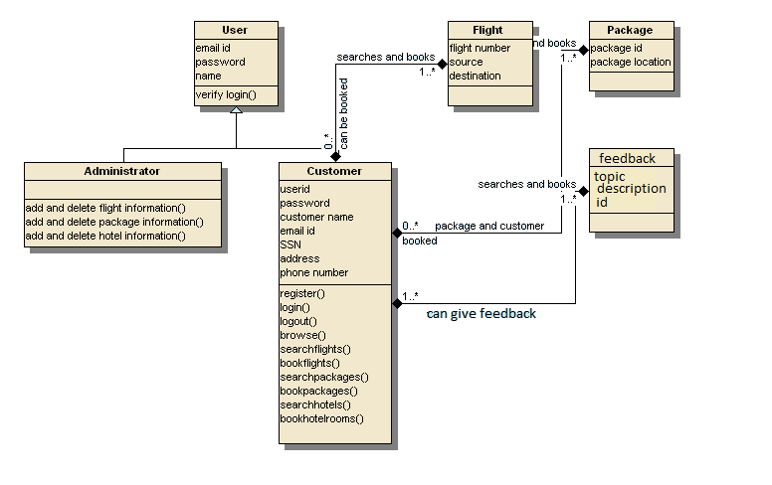

**Sequence Diagram:**

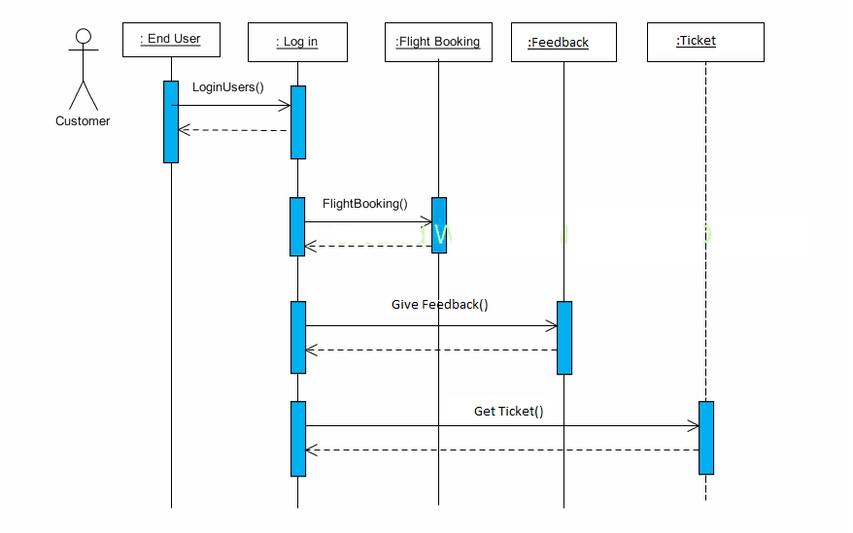

**Technologies Used:**

**HTML**

The Hyper Text Markup Language (HTML) is a collection of platform independent styles, indicated by the markup tags that define invented by Tim Beners Lee while at CERN.HTML documents are plain text that can be created using text editor. We can also use word processing software if we remember to save documents as “text only with line breaks”.

The HTML tags <html>, <head>, <title> and <body> and their corresponding end tags should be used in each HTML file.

**DYNAMIC HYPERTEXT MARKUP LANGUAGE (DHTML)**

With the explosion of interest in the World Wide Web, Hypertext Markup Language (HTML) has assumed a prominent place in the computer world. HTML has evolved to meet the increasing demand for eye-catching and mind-catching web sites.

The end products, static web pages that often required repeated time-consuming round trips between client and server machines, clearly showed a new direction was in order. It combines HTML with Cascading Style Sheets and scripting languages.

**Asp.net:**

ASP.NET is more than the next version of Active Server Pages (ASP); it provides a unified Web development model that includes the services necessary for developers to build enterprise-class Web applications. While ASP.NET is largely syntax compatible with ASP, it also provides a new programming model and infrastructure for more scalable and stable applications that help provide greater protection. You can feel free to augment your existing ASP applications by incrementally adding ASP.NET functionality to them.

ASP.NET is a compiled, .NET-based environment; you can author applications in any .NET compatible language, including Visual Basic .NET, C#, and JScript .NET. Additionally, the entire .NET Framework is available to any ASP.NET application. Developers can easily access the benefits of these technologies, which include the managed common language runtime environment, type safety, inheritance, and so on.

**Sample Code:**

<%@ Page Language="VB" AutoEventWireup="false" CodeFile="Default2.aspx.vb" Inherits="Default2" %>

<!DOCTYPE html PUBLIC "-//W3C//DTD XHTML 1.0 Transitional//EN" "http://www.w3.org/TR/xhtml1/DTD/xhtml1-transitional.dtd">

<html xmlns="http://www.w3.org/1999/xhtml">

<head runat="server">

<title>Untitled Page</title>

<style type="text/css">

.style1

{

color: rgb(255, 255, 255);

font-weight: 700;

}

.style2

{

color: rgb(255, 255, 255);

font-family: "Berlin Sans FB";

}

</style>

</head>

<body bgcolor="#cde8f8"

background="1111111111/Web%20Design%20FP%20Home%20Page%20Background.jpg">

<form id="form1" runat="server">

<div style="width: 1272px">

<asp:Image ID="Image1" runat="server"

ImageUrl="~/1111111111/Flight.jpg" Height="227px" Width="1269px" />

<br />

class="style1"><br />

</span>

<span class="Apple-style-span"

style="font-family: arial, helvetica; font-size: 13px; -webkit-border-horizontal-spacing: 2px; -webkit-border-vertical-spacing: 2px; ">

<span class="style2"

</span>

<span class="Apple-style-span"

style="border-collapse: separate; color: rgb(0, 0, 0); font-family: 'Times New Roman'; font-style: normal; font-variant: normal; font-weight: normal; letter-spacing: normal; line-height: normal; orphans: 2; text-align: -webkit-auto; text-indent: 0px; text-transform: none; white-space: normal; widows: 2; word-spacing: 0px; -webkit-border-horizontal-spacing: 0px; -webkit-border-vertical-spacing: 0px; -webkit-text-decorations-in-effect: none; -webkit-text-size-adjust: auto; -webkit-text-stroke-width: 0px; font-size: medium; ">

<br />

<asp:Image

ID="Image2" runat="server" Height="38px"

ImageUrl="~/1111111111/Welcome_CrashDrop_Steel_k_4.gif" Width="291px" />

<span class="Apple-style-span"

style="border-collapse: separate; color: rgb(0, 0, 0); font-family: 'Times New Roman'; font-style: normal; font-variant: normal; font-weight: normal; letter-spacing: normal; line-height: normal; orphans: 2; text-align: -webkit-auto; text-indent: 0px; text-transform: none; white-space: normal; widows: 2; word-spacing: 0px; -webkit-border-horizontal-spacing: 0px; -webkit-border-vertical-spacing: 0px; -webkit-text-decorations-in-effect: none; -webkit-text-size-adjust: auto; -webkit-text-stroke-width: 0px; font-size: medium; "><span class="Apple-style-span"

style="font-family: arial, helvetica; font-size: 13px; -webkit-border-horizontal-spacing: 2px; -webkit-border-vertical-spacing: 2px; "><asp:Button

ID="Button4" runat="server" Font-Bold="True"

Font-Names="Arial Black" Font-Size="Large" Text="A login"

PostBackUrl="~/admlogin.aspx" />

</span></span>&nbsp;&nbsp;&nbsp;

<span class="Apple-style-span"

PostBackUrl="~/Default3.aspx" />

&nbsp;&nbsp;&nbsp;

<asp:Button ID="Button2" runat="server" Font-Bold="True"

Font-Names="Arial Black" Font-Size="Large" Text="C Signup"

PostBackUrl="~/signup.aspx" />

&nbsp;&nbsp;&nbsp;

<span class="Apple-style-span"

style="border-collapse: separate; color: rgb(0, 0, 0); font-family: 'Times New Roman'; font-style: normal; font-variant: normal; font-weight: normal; letter-spacing: normal; line-height: normal; orphans: 2; text-align: -webkit-auto; text-indent: 0px; text-transform: none; white-space: normal; widows: 2; word-spacing: 0px; -webkit-border-horizontal-spacing: 0px; -webkit-border-vertical-spacing: 0px; -webkit-text-decorations-in-effect: none; -webkit-text-size-adjust: auto; -webkit-text-stroke-width: 0px; font-size: medium; ">

<span class="Apple-style-span"

style="font-family: arial, helvetica; font-size: 13px; -webkit-border-horizontal-spacing: 2px; -webkit-border-vertical-spacing: 2px; ">

<asp:Button ID="Button3" runat="server" Font-Bold="True"

Font-Names="Arial Black" Font-Size="Large" Text="Useful links"

PostBackUrl="~/usefullinks.aspx" />

<

Font-Names="Arial Black" Font-Size="Large" Text="FAQs"

PostBackUrl="~/faq.aspx" />

&nbsp;&nbsp;&nbsp;</span></span></span></span></span></span></span></span></div>

</form>

</body>

</html>

**Snapshots:**

**Home Page:**

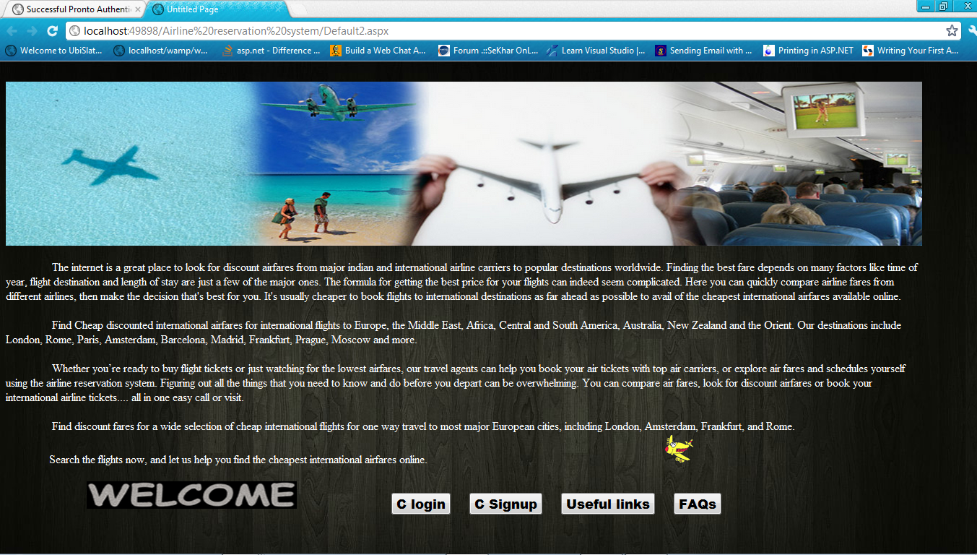

**Personal Account Signup page:**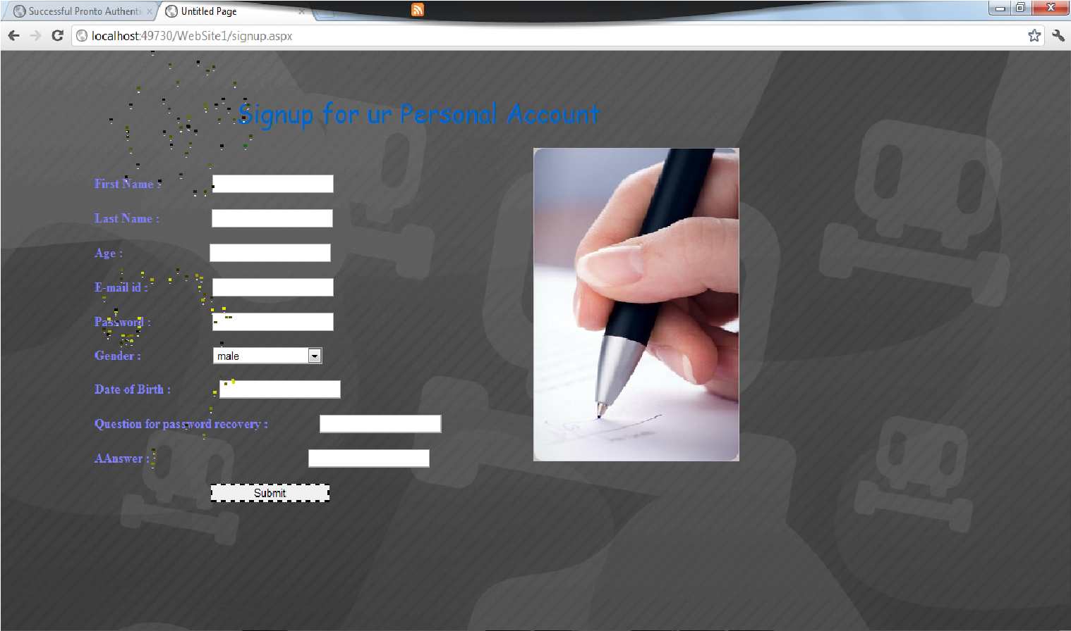

**Login Page:**

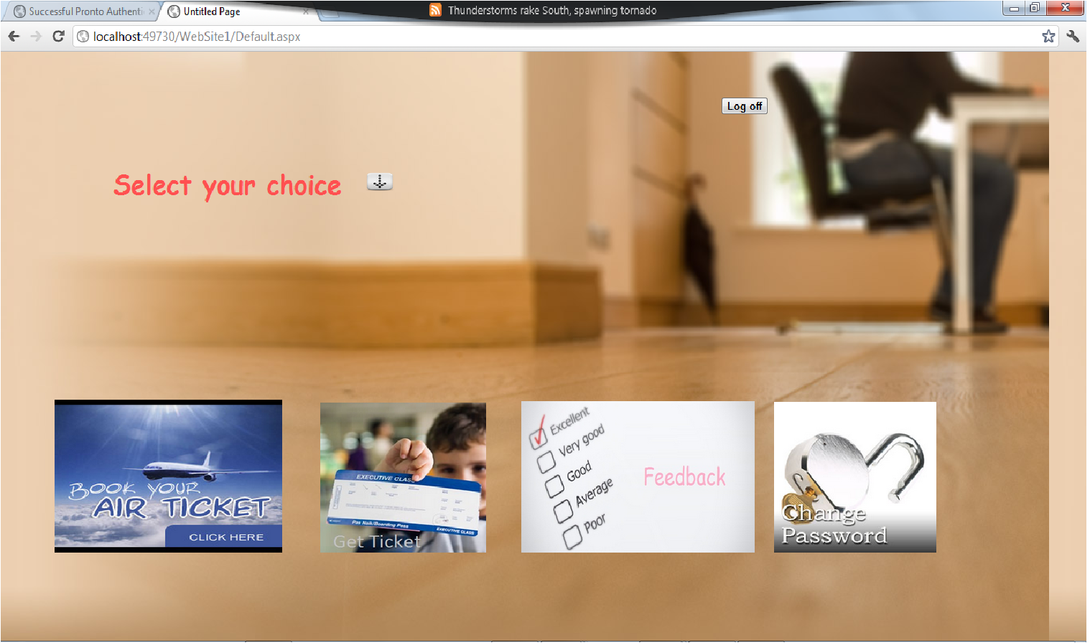

**Ticket:**

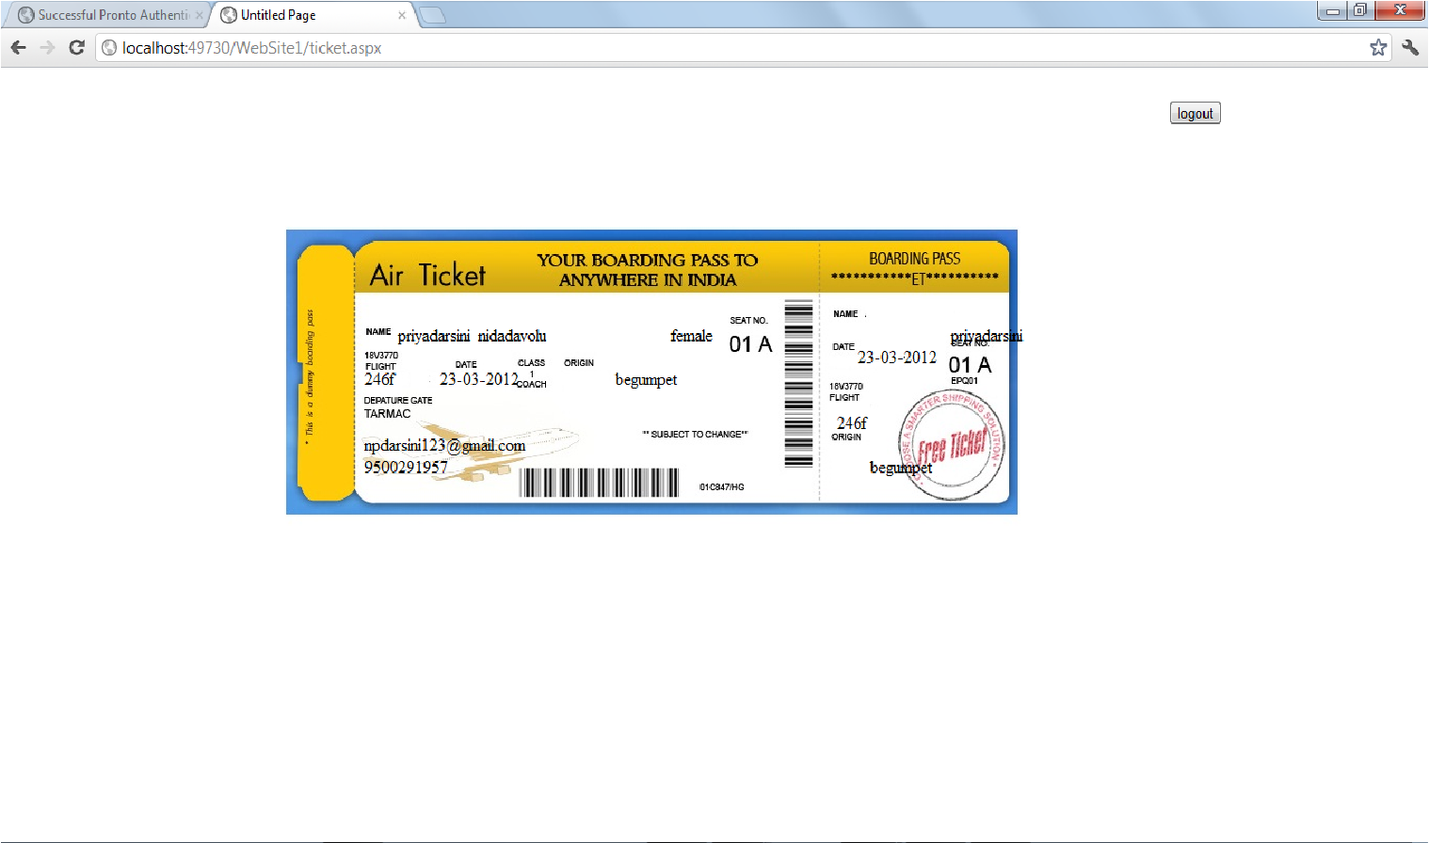

**Password Change Page:**

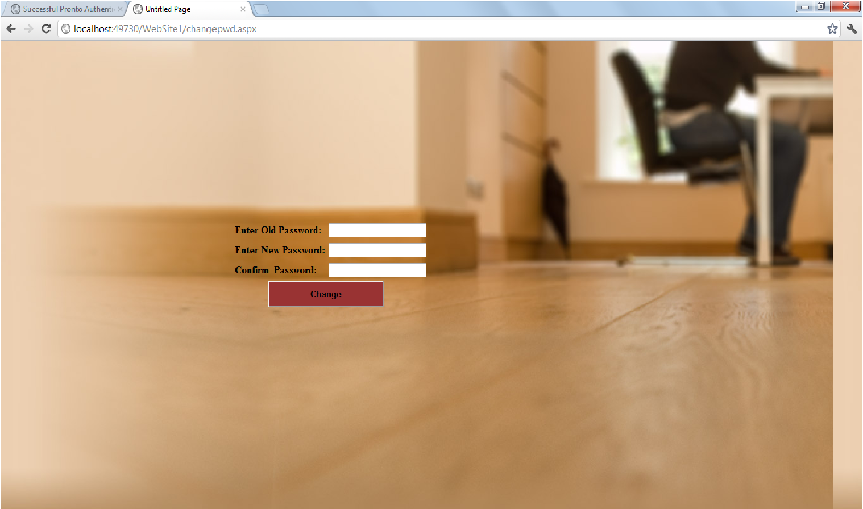

**Signature of the Faculty**